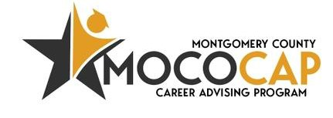
MONTHLY SNAPSHOT

Reporting Period: January 2026

IMPACT
 | TOTAL STUDENT INTERACTIONS | TOTAL UNIQUE STUDENTS | MIDDLE SCHOOL INTERACTIONS | HIGH SCHOOL  INTERACTIONS
Reporting Period | 6,933 | 6,546 | 3,593 | 3,340
Year to Date | 56,400 | 53,709 | 30,079 | 26,321

609 | 3,470 | 1,698 | 1,156
 | 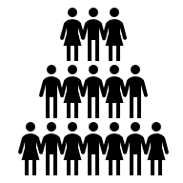 | 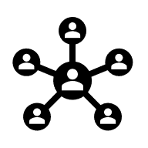 | 
ENGAGED IN SMALL GROUP/1:1 SESSION | ENGAGED IN  LARGE GROUP SESSION | ENGAGED IN  CAREER EXPLORATION | ENGAGED IN  OTHER CAREER ADVISING EXPERIENCE

147,234
TOTAL
STUDENT INTERACTIONS
(ALL TIME)

STUDENT FEEDBACK RESULTS

14,054

TOTAL

STUDENTS

6,217

SENIOR HIGH

7,837

JUNIOR HIGH

Includes student self-reported satisfaction, clarity of next steps,  RIASEC distribution and confidence in achieving career goals. | Career Steps Clarity ★★★★☆ (4/5)  Session Helpfulness ★★★★☆ (4/5)  Confidence in Career Journey ★★★★☆ (4/5)

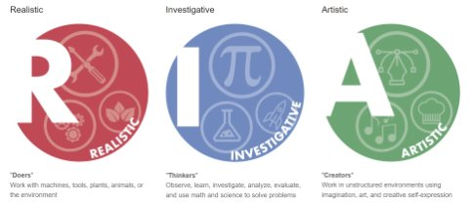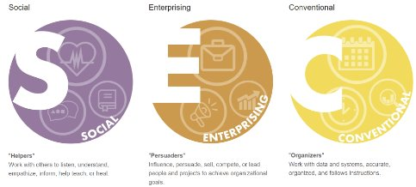
29%
24%
45%
46%
38%
52%
*Note: Youth may identify with more than one RIASEC theme; totals may exceed 100%.

